**Real Estate Consultation Memorandum**

**Date:** 11/15/2023

**To:** Ron Dupage; Rene DuPage

**From:** Thomas Walsh, Hercules Labrakis, Liu Tianci, Matthew Ibalio

**Re:** Apartment Investment Consultation, The DuPages

# **EXECUTIVE SUMMARY**

An analysis has been conducted to evaluate the investment opportunity presented by each of three apartment buildings: The Perennial, The Westchester, and 5700 S Indiana Ave. This analysis was conducted utilizing data sources such as CoStar, STDB, and the websites of competing properties. After close consideration of the data gathered, several of the assumptions included in the broker proforma for the investment have been updated, including: purchase price, expected rental rates, vacancy rates, operating expenses, financing, and sale price. This data was further utilized to conduct an analysis of projected returns of each of the three opportunities at a 12% discount rate, using best-case, worst-case, and most-likely-case scenarios.

It is recommended that Ron pursue the purchase of The Perennial at a targeted purchase price of $12,901,916. The Perennial has a demonstrated and consistent track record for maintaining high occupancy, and is supported by stable population, growing rents and wages, and a favorable location. The property can provide a stable source of returns at the investors’ adopted hurdle rate. Additionally, The Perennial is expected to require the least time and effort to run and maintain the property, which will allow Ron to spend more time traveling and visiting his family.

It is recommended that Rene pursue the purchase of The Westchester at a targeted purchase price of $13,799,217. The Westchester, is supported by a dense population, growing rents and wages, and a favorable location. The proximity to the campus for University of Chicago’s medical campus and law campus are expected to provide a stabilizing effect on demand in the area, and prospective residents can enjoy the numerous amenities the neighborhood has to offer. The Westchester is expected to require more time and maintenance to run than The Perennial, however it is expected to be less cumbersome than the South Indiana property.

## **PROPERTY ANALYSIS**

## **Property Summary and Location – The Perennial**

The Perennial is a 100-unit, 4-story apartment building located on the 2300 block of Black Rd in Joliet, Illinois. All 100 units have two bedrooms and two bathrooms with an average size of 1,100 square feet, which is larger than most two-bedroom units in nearby buildings. The property is of late 60s-early 70s construction, which is consistent with other competitive properties nearby, and it has maintained an occupancy level of 95% for over ten years.

The Perennial sits in a favorable location on Black Rd, offering easy access to major highways such as I-55 and I-80, as well as numerous nearby shopping options. Within approximately 1.5 miles from the subject site, there are numerous grocery stores and national retailers, such as: Jewel Osco, Ross, Hobby Lobby, Burlington, Walmart, Dollar Tree, and Sam’s Club. The property is also located within easy walking distance (0.5 miles) from Ascension Saint Joseph Hospital, which may make it an attractive housing option for hospital employees. The convenient location, large unit size, and above average bathroom count differentiate this property from much of the competition and should allow the property to continue its past trend of strong occupancy.

## **Property Summary and Location – The Westchester**

The Westchester is a 96-unit, elevator serviced high-rise apartment building located on the 1200 block of E 53rd St in the Hyde Park neighborhood of Chicago, Illinois. It contains a mix of Studio, 1-bedroom, and 2-bedroom apartments. Its proximity to the University of Chicago’s schools of Law and Medicine give this property a nearby source of continuous future demand. The surrounding area features numerous amenities such as parks, museums, access to the lake, and other places to visit. In addition, this location has easy access to the trains which provides another form of transportation for those in the building. These features will make the property more desirable to prospective tenants, and in turn make this a more attractive investment.

## **Property Summary and Location – S Indiana Ave**

The final property to be considered is a 72-unit apartment building located on the 5700 Block of S Indiana Ave in Chicago, Illinois. All 72 apartments are two-bedroom-one-bathroom units. Located next to a major highway, it can bring plenty of renters into the area due to its easy access. Additionally, it is near Washington Park which adds an amenity that people can enjoy and one that adds value to the surrounding area.

## **Demographics – The Perennial**

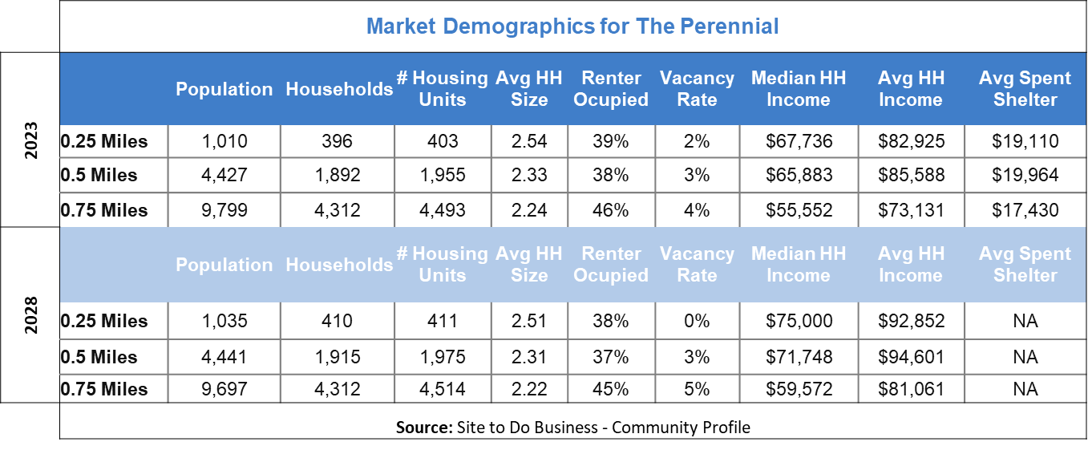Demographic information for the surrounding area was analyzed in radii of 0.25, 0.50, 0.75, 1.0, and 3.0 miles from the property. Current overall demographics for the surrounding area indicate a population that will remain relatively flat with growing wages and a strong percentage of renter-occupied housing. This indicates that housing demand is likely to stay consistent, while reports indicate that no major new housing developments are planned for the next few years, meaning that supply is also expected to remain consistent and therefore that vacancies are not expected to grow.

The high percentage of renter-occupied housing with a vacancy rate of only 4% suggest that the subject property is surrounded by an appropriate demand to continue the strong occupancy which it has enjoyed in the past, and the average household spend on shelter aligns well with market rent comps and projected rents for the subject property (discussed further in the following financial analysis section).

Grouped by Tapestry segment, the largest segments of the population within a ¾ mile radius are made up of “Old and Newcomers” (43.2%), “Metro Fusion” (26.6%), and “Rustbelt Traditions” (12.7%). The Rustbelt Traditions group has the highest home ownership rate of the three (71.2%) as well as being less than half of the size of the next largest group (Metro Fusion). They have a median age of 39 years and an average household size of 2.47. While they will make up a portion of the potential renters for the subject property, the high home-ownership rate and larger family size indicate the primary focus should be on Old and Newcomers, and Metro Fusion.

As indicated in the above table, forecasts from STDB show that the area will remain relatively flat within the ¾ mile radius. Population is projected to contract very slightly; however, number of occupied households is expected to stay the same, indicating that the dip in population is due to reduction to average household size, not out-migration. While vacancy rate is expected to rise slightly to 4.5%, this is due to a small increase in the number of available housing units. Meanwhile, average household income is expected to rise from approximately $73,000 to above $81,000 which will help to support capacity for rent growth.

## **Demographics – The Westchester**

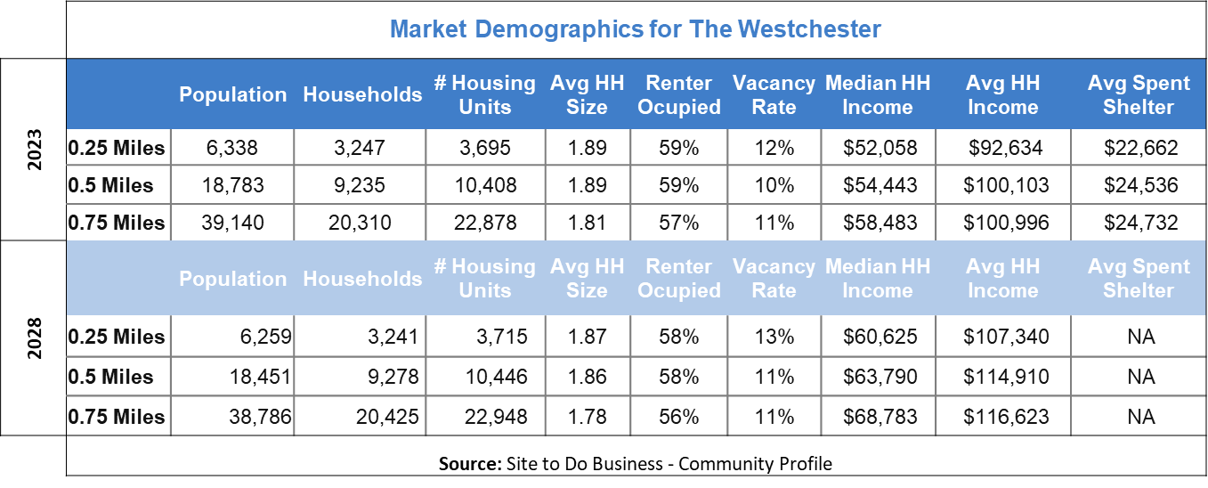Demographic information for the area surrounding The Westchester was analyzed in radii of 0.25, 0.50, 0.75 miles from the property. The property is in a densely populated, affluent area with a high percentage of housing being renter-occupied. This indicates that there is a large base of potential renters to draw from, who can afford to pay for the relatively high rents in the area. While total population is projected to contract slightly, the total number of households is projected to increase, and incomes are projected to continue strong growth. This suggests that the slight decrease in population is likely due to the decreasing average household size rather than a trend of out-migration, and that the area will continue to support high rents and occupancy.

## **Demographics – S Indiana Ave**

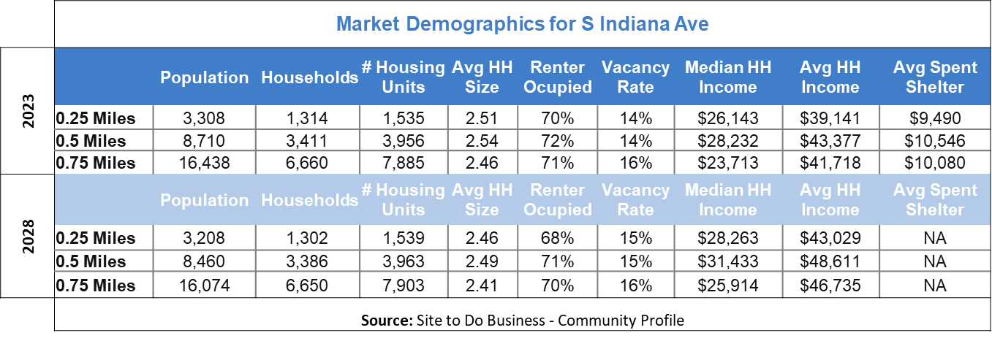

Demographic information for the surrounding area was analyzed in radii of 0.25, 0.50, 0.75 miles from the property. The property is in a densely populated but low-income area. The majority (over 70%) of households are renter-occupied, meaning that the area will not support high rents, but will have a strong demand for apartment units. Projected demographics do show contracting population and household count, indicating that out-migration is expected, and vacancy will continue to rise, albeit marginally.

## **Market – The Perennial**

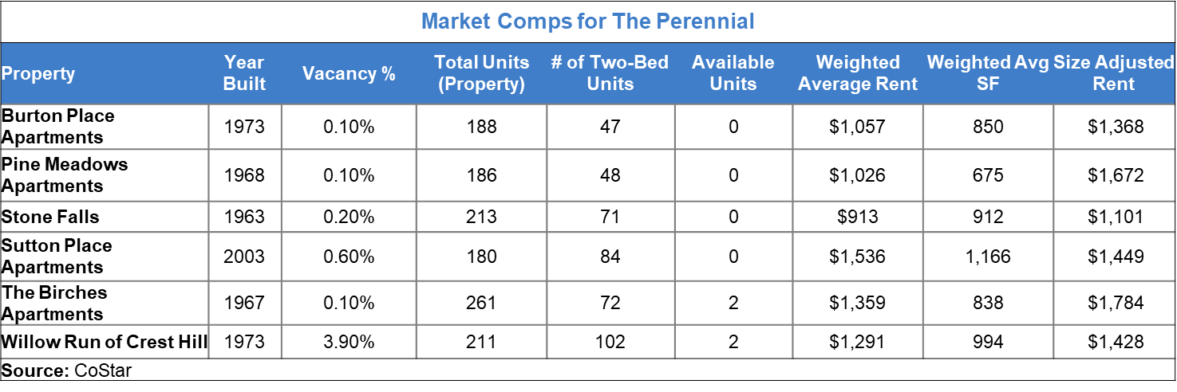

There are 15 apartment buildings which have two-bedroom apartments and are within a ¾ mile radius of the subject property, containing a cumulative total of 667 two-bedroom units, 17 (2.5%) of which are vacant. Only seven of these buildings contain 50 or more total units, but 607 of the 667 two-bedroom units are in these seven properties. While CoStar market data, indicates there are approximately 1,440 total Multi-Family units (760 proposed, and 680 under construction) which are forecasted to be added to the North Will County submarket over the next two years, these projects are not close enough to the subject property to impact the competitive set (primarily in Plainfield, Shorewood, and New Lenox).

Rents and current vacancies at the 7 properties within the competitive set have been evaluated utilizing CoStar to establish realistic expectations for the subject property. Factors which have been considered in weighing the relevancy of respective rents for two-bedroom units, include: comparative age of the building, whether the property contained any affordable housing units, size of units, number of bathrooms, and notable amenities. Larkin Village had the highest number of differences such as numerous affordable housing units, lack of two-bathroom units, free TV/internet, and free heat/water/gas utilities. As a result, it was given the least weight out of the competitive set. Willow Run of Crest Creek was the most comparable property as it is a similar age, and contains a similar number of two bedroom units - most of which have two bathrooms and are only slightly smaller than the units in subject property.

## **Market – The Westchester**

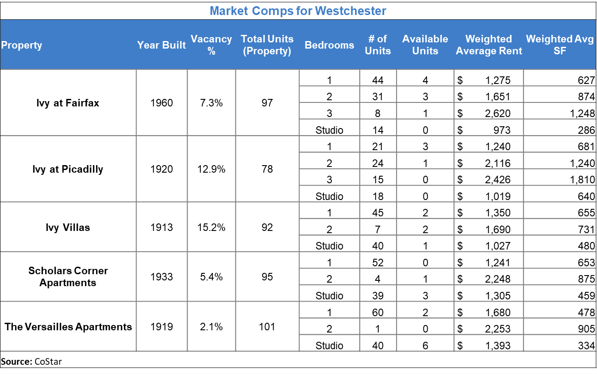

When examining the market for The Westchester, primary focus was placed upon other nearby high-rise apartment buildings with a similar unit mix. Competitive rents were then evaluated and size-adjusted for Studio, 1-bedroom, and 2-bedroom apartments. The low number of available units across the competitive set indicates that the market is supportive of the relatively high rents. The demographic forecast discussed earlier also reinforces that there is not likely to be a significant shift in demand over the near future.

**Market – S Indiana Ave**

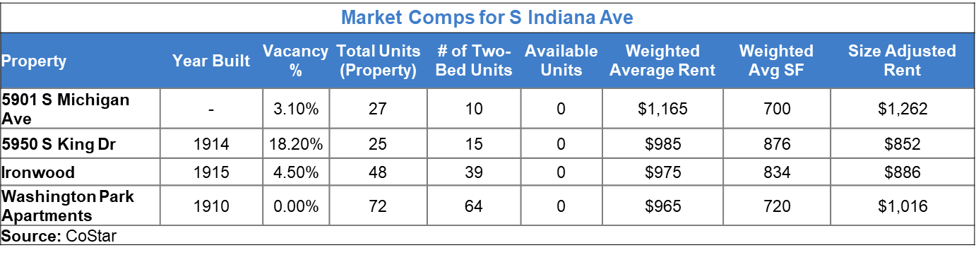

When examining the market surrounding the property at S Indiana Ave, primary focus was placed on nearby non-high-rise apartment buildings with 25 or more units and containing two-bedroom units. The rents of competing properties are relatively low, which means that the potential rents at the subject property will also be limited. While the demographics of the area, as mentioned above, show a high level of general vacancy in the area, properties in the competitive set have no currently available units. This indicates that the competitive set and the subject property are out-performing the market occupancy. While this is a positive sign as it suggests that there is demand for the right type of units, it also means that there is higher vacancy risk, because the property must continue to greatly out-perform the market in order to maintain the current returns.

## **Site/Building Analysis**

Listed as an item, but not included for the purposes of this memo.

# **FINANCIAL ANALYSIS**

## **Assumptions/Broker Proforma Adjustments**

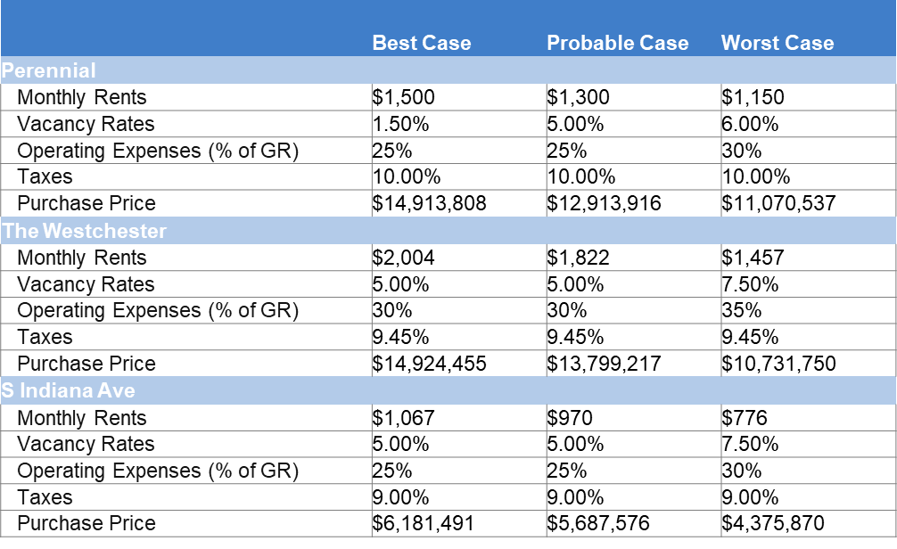

Numerous assumptions from the broker proforma have been adjusted, primarily utilizing data gathered from STDB and CoStar. Assumptions for monthly rents, vacancy rates, and operating expenses were adjusted for each of the three properties based on data gathered to establish the probable case scenario. In determining best-case and worst-case scenarios, each of these factors was adjusted upwards and downwards respectively. Purchase price in each of these scenarios was recalculated to achieve the clients’ desired rate of return.

In the case of The Perennial, the availability of a greater number of published asking and achieved rents allowed for developing specific projections of best-case and worst-case rental rates. Vacancy rates are adjusted to 1.5% in the best-case scenario, as high occupancy of competing buildings indicates that a higher occupancy may be achievable at the Perennial. Operating expenses reflect that expenses are unlikely to decrease in a best-case scenario but may increase in a worst-case scenario.

In the cases of The Westchester and S Indiana Ave, monthly rents in the best-case and worst-case scenarios represent a 10% increase and 20% decrease (respectively) versus the probable case rents. Additionally, both properties reflect that both vacancy and operating expenses are unlikely to decrease in a best-case scenario, though they are likely to increase in a worst-case scenario.

## **Proposed Financing**



Partially-amortizing-constant-payment mortgage loans have been secured for each of the three subject properties. Term length for all three available loans is 10 years, with a 25-year amortization period. The partially amortizing structure of the loans is an attractive option, as it will decrease the debt service costs and increase returns. The loans for The Perennial and The Westchester are both available at a 5.5% rate of interest, while the interest rate available for the loan on the S Indiana Ave property is at 6.5%. It is recommended that all available debt be utilized in the respective purchases due to the below-market interest rates.

## **Best Case Analysis – The Perennial**

In a best-case scenario, rents may achieve $1,500 per month, vacancy at the property may be as low as 1.5%, and Operating Expenses (excluding Real Estate Taxes) will hold at approximately 25% of Potential Gross Income. This results in a year 1 NOI of $1,088,000 and a projected sale price of $19,725,952 based on a 7.5% exit cap rate. Total NPV for the investment in this scenario is $0 with an IRR of 12.00%.

## **Best Case Analysis – The Westchester**

In a best-case scenario, rents may achieve $2,004 per month, vacancy will hold at 5%, and Operating Expenses (excluding Real Estate Taxes) will hold at approximately 30% of Potential Gross Income. This results in a year 1 NOI of $1,244,432 and a projected sale price of $22,457,880 based on a 7.5% exit cap rate. Total NPV for the investment in this scenario is $0 with an IRR of 12.00%.

## **Best Case Analysis – S Indiana Ave**

In a best-case scenario, rents may achieve $1,067 per month, vacancy will hold at 5%, and Operating Expenses (excluding Real Estate Taxes) will hold at approximately 25% of Potential Gross Income. This results in a year 1 NOI of $507,752 and a projected sale price of $9,326,875 based on a 7.5% exit cap rate. Total NPV for the investment in this scenario is $0 with an IRR of 12.00%.

## **Worst Case Analysis – The Perennial**

In a worst-case scenario, rents may fall as low as $1,150 per month, vacancy at the property may be as high as 6%, and Operating Expenses (excluding Real Estate Taxes) will increase to approximately 30% of Potential Gross Income. This results in a year 1 NOI of $690,200 and a projected sale price of $12,597,820 based on a 7.5% exit cap rate. Total NPV for the investment in this scenario is $0 with an IRR of 12.00%.

## **Worst Case Analysis – The Westchester**

In a worst-case scenario, rents may fall as low as $1,457 per month, vacancy at the property may be as high as 7.5%, and Operating Expenses (excluding Real Estate Taxes) will increase to approximately 35% of Potential Gross Income. This results in a year 1 NOI of $768,501 and a projected sale price of $14,681,654 based on a 7.5% exit cap rate. Total NPV for the investment in this scenario is $0 with an IRR of 12.00%.

## **Worst Case Analysis – S Indiana Ave**

In a worst-case scenario, rents may fall as low as $776 per month, vacancy at the property may be as high as 7.5%, and Operating Expenses (excluding Real Estate Taxes) will increase to approximately 30% of Potential Gross Income. This results in a year 1 NOI of $304,098 and a projected sale price of $5,977.982 based on a 7.5% exit cap rate. Total NPV for the investment in this scenario is $0 with an IRR of 12.00%.

## **Probable Case Analysis – The Perennial**

In a probable-case scenario, rents will be $1,300 per month, vacancy at the property will remain at 5%, and Operating Expenses (excluding Real Estate Taxes) will remain at 25% of Potential Gross Income. This results in a year 1 NOI of $881,000 and a projected sale price of $16,016,743 based on a 7.5% exit cap rate. Total NPV for the investment in this scenario is $0 with an IRR of 12.00%.

## **Probable Case Analysis – The Westchester**

In a probable-case scenario, rents will be $1,822 per month, vacancy at the property will remain at 5%, and Operating Expenses (excluding Real Estate Taxes) will remain at 30% of Potential Gross Income. This results in a year 1 NOI of $1,127,963 and a projected sale price of $20,370,897 based on a 7.5% exit cap rate. Total NPV for the investment in this scenario is $0 with an IRR of 12.00%.

## **Probable Case Analysis – S Indiana Ave**

In a probable-case scenario, rents will be $970 per month, vacancy at the property will remain at 5%, and Operating Expenses (excluding Real Estate Taxes) will remain at 25% of Potential Gross Income. This results in a year 1 NOI of $456,629 and a projected sale price of $8,410,810 based on a 7.5% exit cap rate. Total NPV for the investment in this scenario is $0 with an IRR of 12.00%.

## **Partitioned IRR**



For each of the three scenarios calculated at each of the three subject properties, NPV of the investment is calculated at $0, and IRR is calculated to be 12%. The above snapshot breaks down key return metrics for the probable case scenario for each of the three properties. Detailed calculations are available for all scenarios at each of the properties in the excel workbook which has been provided separately.

Of the three properties, The Westchester provides the highest cash-on-cash return rate before and after tax, followed by South Indiana, and lastly by The Perennial. This is important to consider, as it is an indication of how much return will actually be received on the investment during the holding period.

The Partitioned IRR is a useful way to quantify how much of the total potential return comes from regular operations of the property versus from the assumed sale price. When examining the Partitioned IRR at the three properties, the property at South Indiana has the highest percent of returns attributable to operations, followed by The Westchester, and finally The Perennial. Generally, a greater percentage of the IRR that is attributable to the assumed sale price equates to greater risk of not achieving the projected returns due to the unpredictability of future sale prices; however, the property at S Indiana Ave is believed to have a higher probability of experiencing a worst-case scenario.

# **RECOMMENDATIONS**

It is recommended that Ron pursue the purchase of The Perennial. The Perennial has a demonstrated and consistent track record for maintaining high occupancy, and is supported by stable population, growing rents and wages, and a favorable location. The property can provide a stable source of returns at the investors’ adopted hurdle rate. Additionally, The Perennial is expected to require the least time and effort to run and maintain the property, which will allow Ron to spend more time traveling and visiting his family.

It is recommended to submit an initial bid for The Perennial of $11,070,537 to leave some room for negotiation and counter-offers, and target a final purchase price of $12,913,916. In no event should Ron exceed a purchase price of $14,913,808, above which the investment is unlikely to yield the desired return even in favorable market conditions.

It is recommended that Rene pursue the purchase of The Westchester. The Westchester, is supported by a dense population, growing rents and wages, and a favorable location. The proximity to the campus for University of Chicago’s medical campus and law campus are expected to provide a stabilizing effect on demand in the area, and prospective residents can enjoy the numerous amenities the neighborhood has to offer. The Westchester is expected to require more time and maintenance to run than The Perennial, however it is expected to be less cumbersome than the South Indiana property.

It is recommended to submit an initial bid for The Westchester of $10,731,750 to leave some room for negotiation and counter-offers, and target a final purchase price of $13,799,217. In no event should Ron exceed a purchase price of $14,924,455, above which the investment is unlikely to yield the desired return even in favorable market conditions.

The purchase of the property on South Indiana Ave is not recommended for either Ron or Rene at this time. While the property does make an attractive investment opportunity financially, the high vacancy and crime in the area and low rents and wages mean that this property is likely to require a large amount of time and attention to run, which does not fit with either of the DuPages’ goals.

# **EXHIBITS**

## EXHIBIT I – CoStar Will County Unit Deliveries – The Perennial

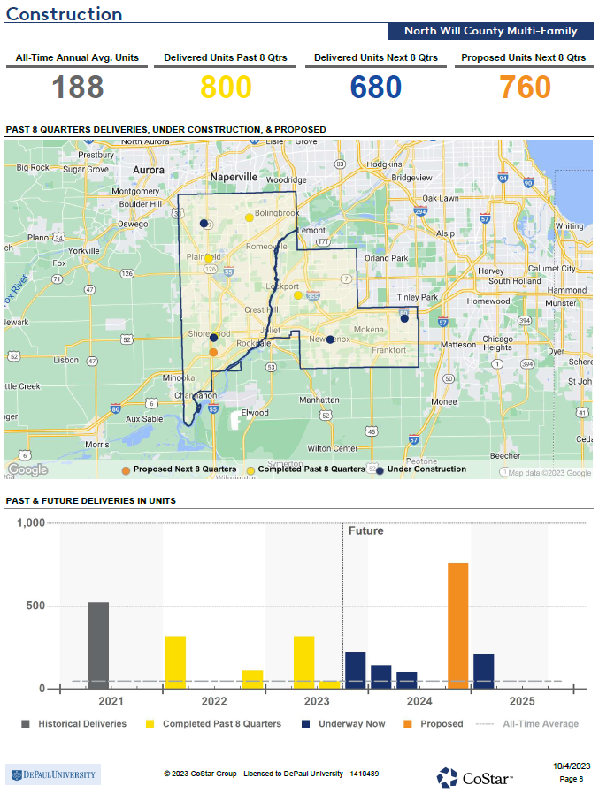



## EXHIBIT II – Tapestry Segmentation, Top Segments

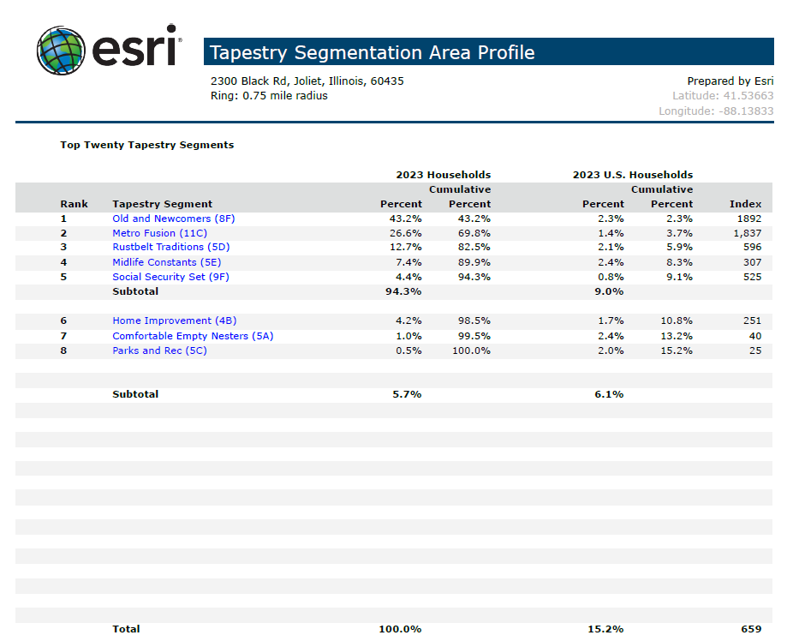



## EXHIBIT III – STDB Community Profile

## 

## 

## EXHIBIT IV – STDB ACS Housing Summary

## 

